PATIENT NAME: Willingham, Howard
INSURANCE ID#: 150221026 DOB: 02-28-1968
ADDRESS: 1343 N Cleveland Ave Apt 204 Chicago IL 60610
PHONE #: 312-579-8466
MEDICARE DESCRIPTION AND PROCEDURE CODES:
- POWER WHEELCHAIR GROUP STANDARD CAPTAIN CHAIR K0825 #1;
- BATTERY E2361 #2

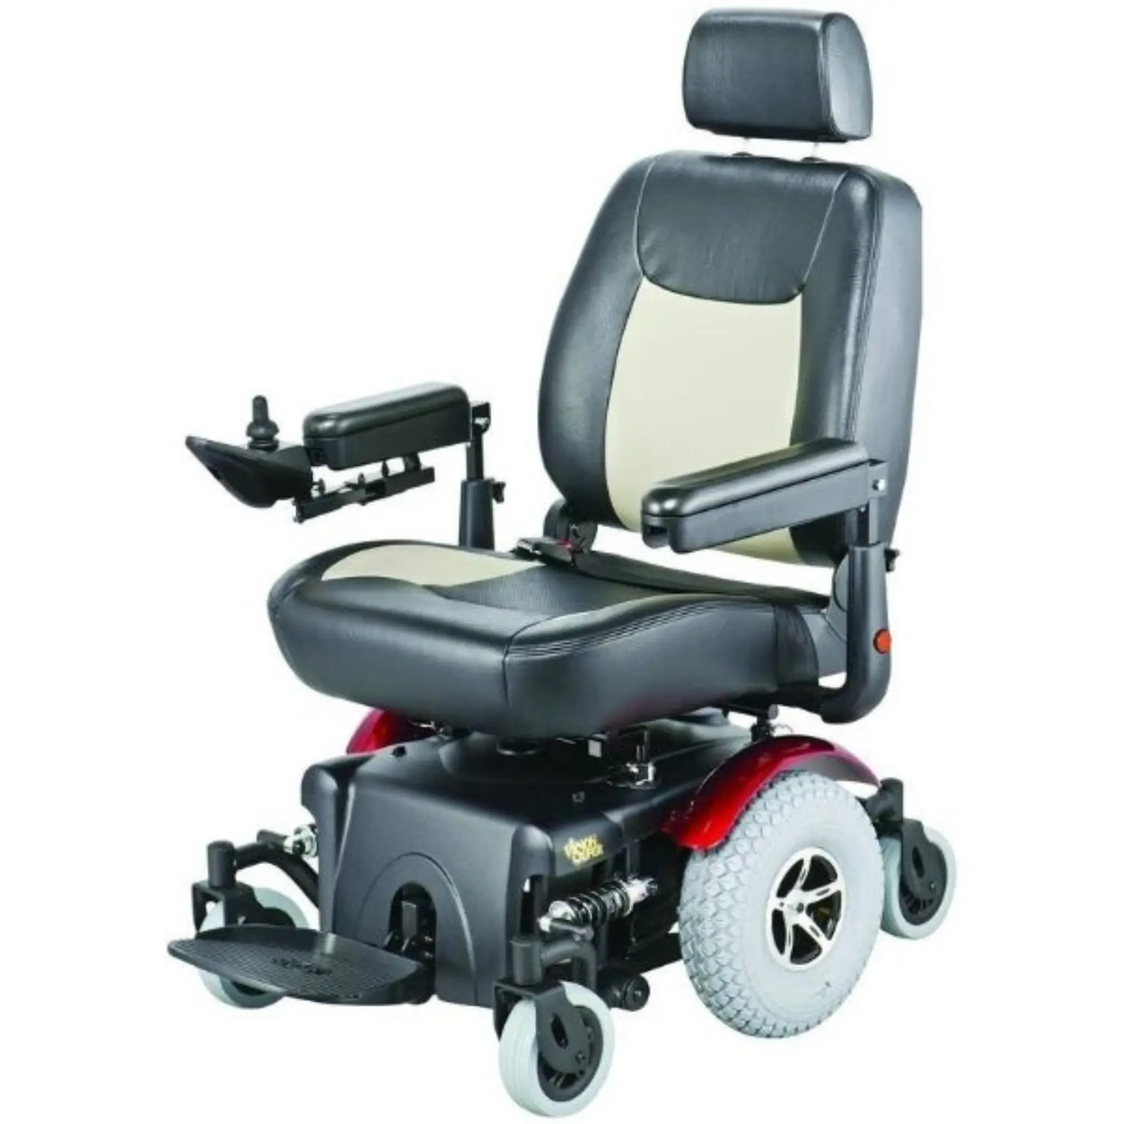
VISION SUPER P327

F e at u r e s:
• True mid-wheel drive: 20.7” turning radius
• Robust independent suspension can absorb up to 350 lbs on the footplate without tipping forward
• Premium, semi-reclining ergonomic seat, up to 135°
• 12” knobby drive tires for superior traction
• Dynamic LiNX & Shark controller for convenient Bluetooth programming and diagnostics
• 20” seat width with 18”-20” depth adjustability • 22” or 24” seat widths with 20”-22” depth adjustability.
• Red and blue color fenders included

S p e c i f i c at i o n s M o d e l s :
Weight Capacity 450 lbs, 400 lbs (with power seat lift)
Maximum Speed 5 mph
Per-Charge Range 20 miles
Batteries 22NF (55Ah)
Ground Clearance 2.2"
Turning Radius 20.7"
Overall Length 35"
Overall Width 27"
Drive Wheels 12" flat-free
Casters 6" front, 6" rear
Suspension TruStep 21"-23" (captain), 17.5"-19.5" (pan)
Seat Depth 18", 19", 20", 21" or 22"
Backrest Height 20" or 22"
Power Seat Lift 10" scissor (P3274)
Controller LiNX, PG VR2 (for power seat lift) 18 Months : Motor and Electronics 5 Year/ Limited Liftetime Frame 1 Year Battery

**Patient Agreement:** I, ___________________________________ (Patient Name), acknowledge that I have reviewed the power wheelchair depicted in the accompanying picture. I understand its features and specifications and agree that this wheelchair meets my mobility needs as assessed by my healthcare provider. I consent to accept and use this specific power wheelchair as part of my mobility solution.

Patient’s Signature:__________________________________________________________ Date:_____________
Signature if other than patient:___________________________________Relationship:____________________
Name if other than patient:______________________________________________________________________
Reason patient is unable to sign:__________________________________________________________________
Evaluator’s Signature:_____________________________________________________ Date:________________
Evaluator’s Name (printed):_____________________________________________________________________

